The effective drought index(EDI)
Current drought indices, even some of them are very popular, appear to have some shortcomings. For instance, time unit of assessment is sometimes too long (a month or a longer time period). But the daily time unit should be used because water amount of an affected region by drought can return to normal conditions with only a day's rainfall. Another problem is the storing term of water resources. Soil moisture is soon influenced by a recent deficiency of precipitation, but water resource deficiencies in reservoirs or other sources are affected by much longer-term precipitation totals. Furthermore, the values of some parameters which are used in the calculation of the indices are difficult to be estimated; for example soil moisture and evapotranspiration. Moreover, the consideration of diminishing of water resources over time may not be realistic. Thus, simple summation of precipitation may not provide good results in detecting the water deficiency. The characteristics of current drought indices are summarized in Table 1.
Table 1. Characteristics of drought indices (Byun and Wilhite 1999)

Name | Used factors | Time scale | Main concept | Source, year created
EDI | r | d | A standardized index using effective precipitation(EP) the summed value of daily precipitation with a time-dependent reduction | Byun and Wilhite(1999)
PDSI | r,t,et,sm,rf | m(2w) | Based on moisture input, output, and storage. Simplified soil moisture budget. | Palmer(1965)
Deciles | r | m | Diving the distribution of the occurrences over a long-term r record into sections, each represents 10%. | Gibbs and Maher(1967)
CMI | r,t | w | Like the PDSI, except considering available moisture in top 5 ft of soil profile. | Palmer(1968)
SPI | r | 3m,6m,12m, 24m, 48m | Standardized anomaly for multiple time-scale after mapping probability of exceedance from a skewed distribution | McKee et al(1993)

* Abbreviations: P-factors used in PDSI, r-precipitation, et-evapotranspiration, t-temperature, sm-soil moisture, rf-runoff, sn-snowpack, st-streamflow, rs-reservoir storage, w-week, m-month, s-season, yr-year, c-century, 3 m-3 months.

Byun and Wilhite (1999) proposed a new concept of method to solve the mentioned weaknesses of the current indices and to improve drought monitoring. The innovations of that method are the use of daily precipitation height values and the introduction of a new concept, Effective Precipitation (EP). The EP is the summed value of daily precipitation with a time-dependant reduction function. Thus, the only data needed for the calculation of the drought indices series of that method is daily precipitation height values. The EP, which represents daily depletion of water resources, is calculated using the equation:

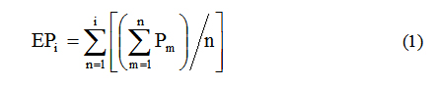

where Pm is the precipitation m days before and the index i represents the duration of summation (DS) in days. Here i=365 is used, that is, summation for a year which is the most dominant precipitation cycle worldwide. The 365 can then be a representative value of the total water resources available or stored for a long time. In other cases, when the study is focused on water resources which are stored for a short time, a smaller value of i can be used, for example i=15. For the calculation of EP, various equations have been proposed but equation (1) is the most appropriate to represent the depletion of water resources (Lee 1998, Shim et al. 1998).
Once the daily EP is computed, a series of indices can be calculated to highlight different characteristics of a station's water resources. The first step is the calculation of Mean Effective Precipitation (MEP). This is the about climatological mean of the EP. The MEP illustrates the climatological mean of stored water quantity. The calculation method of MEP is as follows. Method 1) MEP is calculated by averaged EP for 30 years. Method 2) MEP is a EP calculated by using averaged precipitation for 30 years.(※This web page calculates MEP using method 2.)
The second step is to calculate the Deviation of EP (DEP) from the MEP:
The DEP shows the deficiency or surplus of water resources for a particular date and place.
The next step is the calculation of the Standardized value of DEP (EDI):
Where the ST(DEP) denotes the standard deviation of each day's DEP.The EDI expresses the standardized deficit or surplus of stored water quantity. The EDI enables one location's drought severity to be compared to another location's, regardless of climatic differences. The use of the EDI has been tested in several drought studies (Byun and Lee 2002; Moghaddasi et al.; 2004; Kang and Byun 2004; Kim and Byun 2006; Morid et al. 2006).

The classification of the drought severity by the Effective Drought Index

In spring

-0.5 > EDI : Moderate Drought
-1.0 > EDI : Severe Drought
-2.0 > EDI : Extreme Drought

In rainy season

-1.0 > EDI : Moderate Drought
-2.0 > EDI : Severe Drought
-3.0 > EDI : Extreme Drought

Other season

-0.7 > EDI : Moderate Drought
-1.5 > EDI : Severe Drought
-2.5 > EDI : Extreme Drought

| References |
*Akhtari, R., S. Morid, M. H. Mahdian, and V. Smakhin, 2008: Assessment of areal interpolation methods for spatial analysis of SPI and EDI drought indices. Int. J. Climatol., Published online, DOI: 10.1002/joc.1691.
*Byun, H. R.and D. K. Lee, 2002: Defining three rainy seasons and the hydrological summer monsoon in Koreausing available water resources index. J. Meteor. Soc. Japan, 80, 33-44.
*Kang, K. A. and H. R. Byun, 2004: On the developing processes of the climatological drought over the East Asia in 1982. J. Kor. Met. Soc., 40, 467-483.
*Kim, Y. W., and H. R. Byun, 2006: On the causes of summer droughts in Korea and their return to normal. J. Kor. Met. Soc, 42, 237-251.
*Lee, S. H., 1998: Flood simulation with the variation of runoff coefficient in tank model. J. Korean Water Resour. Assoc., 31, 3-12.
*Morid S., V. Smakhtin, and M. Moghaddasi, 2006: Comparison of seven meteorological indices for drought monitoring in Iran. Int. J. Climatol., 26, 971-985.
*Shim, S. B., M. S. Kim, and K. C. Shim, 1998: Flood inflow forecasting on multipurpose reservoir by neural network. J. Korean Water Resour. Assoc., 31, 45-58.
*Smakhtin, V. U. and D. A. Hughes, 2007: Automated estimation and analyses of meteorological drought characteristics from monthly rainfall data. Environ. Model. Software., 22, 880-890.
*Yamaguchi, Y. and M. Shinoda, 2002. Soil moisture modeling based on multiyear observations in the Sahel. J. Appl. Meteo., 41, 1140-1146.

EDI - Effective Drought Index
Indice che considera l’accumulo o il deficit di acqua giornaliero ed è funzione della pioggia necessaria al rientro dei parametri alla normalità, ovvero il recupero dopo il deficit accumulato a partire dall’insorgere di un evento siccitoso.
Si basa sul concetto di “precipitazione effettiva”, ovvero la somma della pioggia giornaliera con una funzione di riduzione legata al tempo (Byun & Wilhite, 1999).
Permette una rapida e precisa misura del livello corrente della risorsa idrica a disposizione e soprattutto consente l’individuazione di siccità anche di breve periodo.
Come per lo SPI, la standardizzazione permette il confronto fra stazioni collocate in aree geografiche e climatiche diverse.
La “precipitazione effettiva”, che indica la riduzione giornaliera della risorsa idrica, viene calcolata con la seguente equazione:

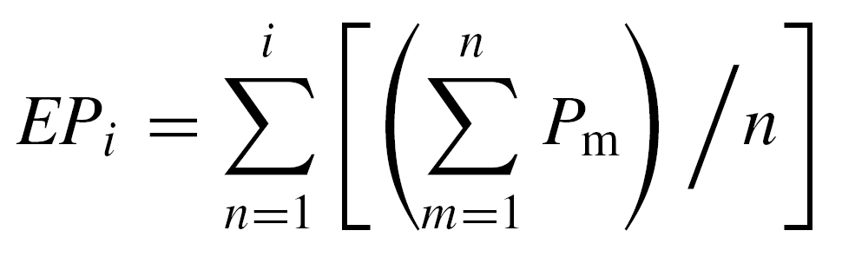
dove Pm è la pioggia m giorni prima; i rappresenta il numero di giorni durante i quali le piogge sono sommate per calcolare l’intensità della siccità. Di solito i è pari a 365 giorni, in quanto un anno può essere rappresentativo delle risorse idriche disponibili o immagazzinate per un lungo periodo.
Una volta calcolata la pioggia effettiva EP_{i} e la pioggia effettiva media climatologica (MEP), viene calcolata la deviazione della precipitazione effettiva (DEP) dalla media (MEP) che indica un deficit o surplus di acqua per un dato giorno e luogo:
DEP = EP - MEP
Infine viene effettuato il computo del valore standardizzato della DEP, ovvero l’EDI:
EDI = DEP / ST(DEP)
dove ST(DEP) e la deviazione standard di ciascun DEP giornaliero.
Utilizzando valori giornalieri nell’elaborazione dell’indice, è più facile che, nell’andamento generale, si evidenzino dei picchi in cui precipitazioni abbondanti facciano ritornare, più o meno temporaneamente, la situazione nella norma.

La tabella seguente indica le classi di siccità o surplus in base ai valori dell’indice:

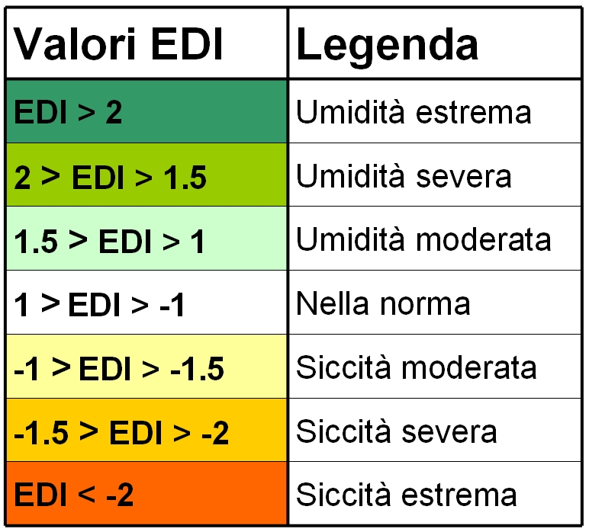

I dati di pioggia derivano dalle stazioni del Consorzio LaMMA, dell'Aeronautica Militare e del Servizio Idrologico Regionale.

Riferimenti bibliografici:
Byun HR., Wilhite D. A. (1999). Objective Quantification of Drought Severity and Duration. Journal of Climate. 12, 2747-2756.

